Class Project (Milestone 1):

“The Employee-Project Hours Prototype”

In this project you are asked to create a C# Windows application that will allow employees and managers to interact with a database called “EmployeeProjects”. This database tracks the hours that employees have on a given project. The database design is shown in the following image.

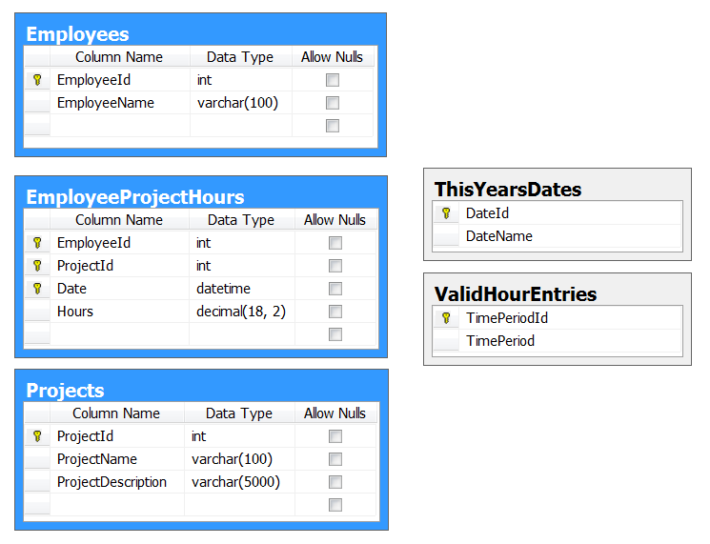

- Create the database and tables, please review and run the following SQL Script
"EmployeeProjects Database Script.sql"

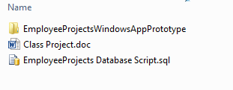
2) Create Interfaces to match the database objects (Both tables and stored procedures!)

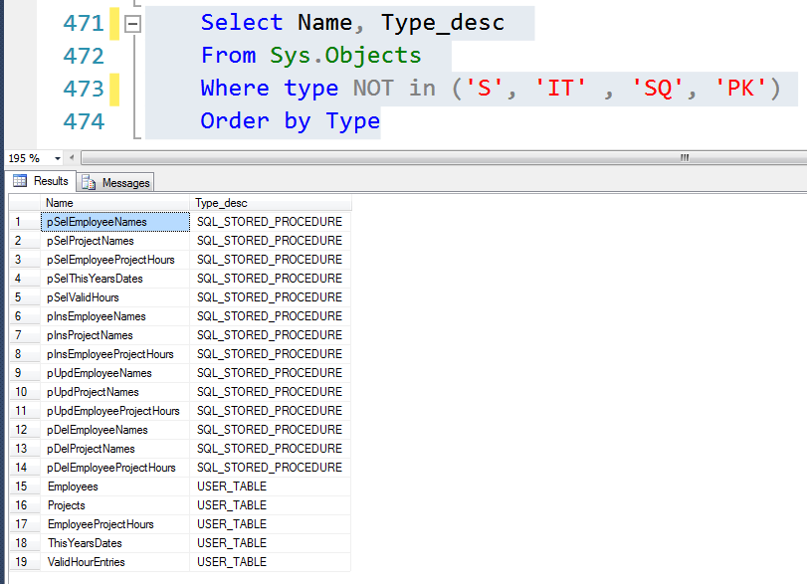

Recommend Research:

Chapter 13 Using Windows Form Controls - CodeProject
http://www.codeproject.com/Articles/1465/Beginning-C-Chapter-13-Using-Windows-Form-Controls

Randal's Videos on ADO.NET and SQL
https://docs.google.com/folder/d/0B5U6tT4eiM6aMWViYzk1MzItNjc5My00YmJhLWEzODQtMDY2NGFmMDg0MGE2/edit

